**Fix OneDrive Sync Problems**

**Getting to know OneDrive for Windows**

 OneDrive sync error

 OneDrive processing changes

 OneDrive paused

 OneDrive account nearly full

 OneDrive account full, locked or frozen

 OneDrive not signed in

 OneDrive old version

Fix OneDrive sync error below:

**Method 1**

1. Select the blue cloud icon in the notification area



1. Select **Help & Settings** > **Pause syncing** > **2 hours**

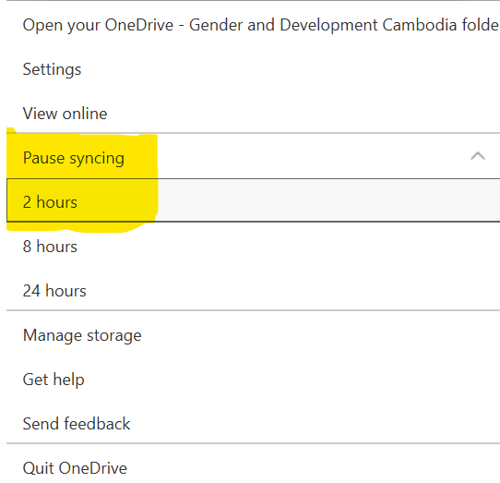

And then select **Resume Syncing**

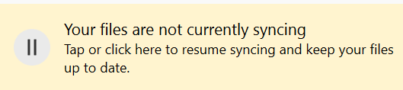

**Method 2**

1. Select the **blue** cloud icon in the notification area



1. Select **Help & Settings** > **Settings**

Select **Account** Tab > **Unlink this PC** and then **Sign In** with your email account, wait a second it will be syncing to complete.

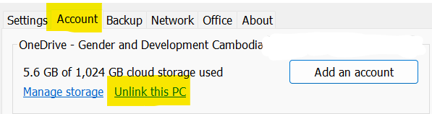

**Method 3**

1. Select the **blue** cloud icon in the notification area



1. Select **Help & Settings** > **Quit OneDrive**

And then run **OneDrive** back again, by typing “OneDrive” on a search box and then select

**OneDrive** to run it.

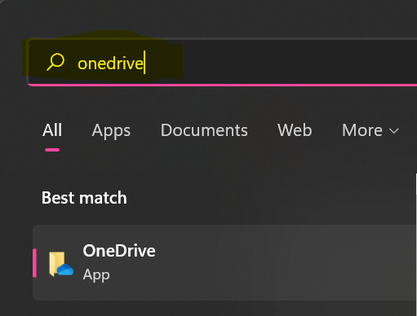

**Method 4**

Move files out of a sync folder



1. Select the **blue** cloud icon in the notification area



1. Select **Help & Settings** > **Pause Syncing > 2 hours**

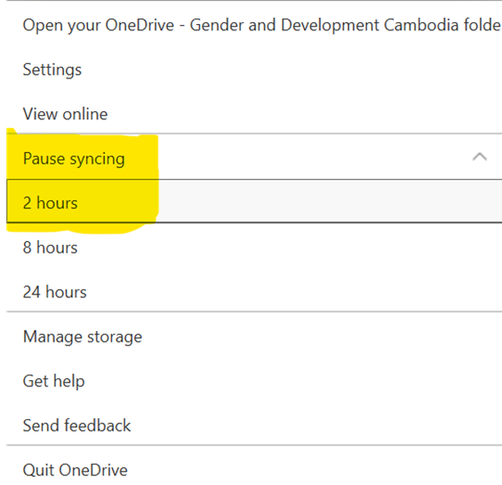

1. Select a file from one of your sync folders and move it to a folder that’s not part of OneDrive, e.g. drive (D:\...)
2. Go to step (2) to select **Resume Syncing**

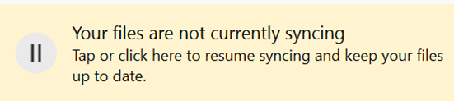

1. Once sync is complete, move the file back again

**Make sure the filenames and file types are supported**

There are three types of constraint with OneDrive files and filenames:

1. Make sure that none of the files you want to sync are larger than 15GB.
2. Make sure the entire file path, including the file name, contains fewer than 400 characters.

C:\Users\<UserName>\Pictures\Saved\2017\December\Holiday\NewYears\Family…

To resolve this, shorten the name of your file or the name of subfolders in OneDrive or select a subfolder that’s closer to the top-level folder.

1. Make sure that your file doesn't contain any illegal characters (such as <, >, :, ", |, ?, *, /, \) or that the folder includes any unsupported file types.

**Turn off Office Upload**

1. Select the blue icon in the notification area



1. Select **Help & Settings > Settings >**

**Office** Tab > Uncheck “**Use Office Applications to sync Office files that I Open**”

**Note**: when you turn off the **Use Office Applications to sync office files that I Open** settings, any changes that you and other people make to office files in your OneDrive will no longer merge together automatically.

**Finish**